**Hakurei Talisman Factory**

Prototype feature description

Gray text represents features not in the prototype.

**Core description**

Hakurei Talisman Factory is a Virtual Reality FPS fighting game that includes talisman customization system for the player to design him or her own talisman and use talisman as a firearm to fight against the enemies. In the game, the player will first navigate to the talisman customization scene and start to build his or her unique weapon with different strokes. Each stroke has its special effects on attacking the enemies. The stroke combination in the talisman will strategically affect how easily and hardly the player will win the fight. When the player finished customizing talisman, the game will start. The target of the player is destroyed Hakurei’s factory as much as the player can, and finally find out Hakurei to engage the final fight against her. If Hakurei is defeated by the player, the player will win the game.

**Player**

In the game, the player has First Person View and holds talisman as his or her weapon. Talisman customization system has 3 talisman frames and 15 strokes.

Talisman (3 frames):

Small Talisman - 4 Stroke slots;

Medium Talisman - 8 Stroke slots;

Large Talisman - 16 Stroke slots;

Strokes (15 strokes):

The player can use each stroke more than once.

**Game scene**

When the player finished your talisman, the game starts and the player will enter the main game scene. The main scene is a huge talisman factory with a lot of facilities and equipment for producing talisman. The player’s object is to destroy this factory and try to find where Hakurei is. The position of Hakurei is set randomly in the game. So the player doesn't know where she is and should try the best to find her out. Defeat her and win the game.

**Movement**

In Hakurei Talisman Factory, the player can look around by rotating his or her head. The game has gyroscope so that can motion tracking the head movement. The player will also hold a wireless Xbox controller and move around by moving left-joystick, and fire the weapon (customized talisman) by pressing and holding ButtonA.

**The Enemy**

Hakurei is the only enemy and the final boss of the game. Her actions are generated correspondingly to the strokes that the player chose in the talisman customization system.

Hakurei actions:

Throw Fireball;

Throw Large Fireball and burn a sport area for 30 second;

Emission laser beam with purple flashing light

Set traps;

Flip boom or grenade;

Generate 10 counterparts of herself to confuse the player;

Flash move to the back of the player;

Melee attack with katana;

**Challenges:**

Hakurei’s position is randomly set so that the player should spot her position in the huge factory. Hakurei is very powerful. The player should well consider the combination of talisman to fight against her. Hakurei has special moves and actions list above. The player needs to avoid her attack, traps, and magic on the fighting stage.

**Win condition**

There is a scoring system in the game. The more facilities and equipment the player destroyed the more score the player will gain. Find out Hakurei as quick as the player can, the more score will set to the player. More combo attack to Hakurei will assign more extra score to the player. The player and Hakurei both have a certain amount of HP. If the player’s HP to 0, the player loses and the game is over. If Hakurei’s HP is 0, she will die and the player wins the game. The final scene will list the score the player gained, the number of combo attacks, HP lost and total game time.

**Hakurei Talisman Factory**

Flowchart

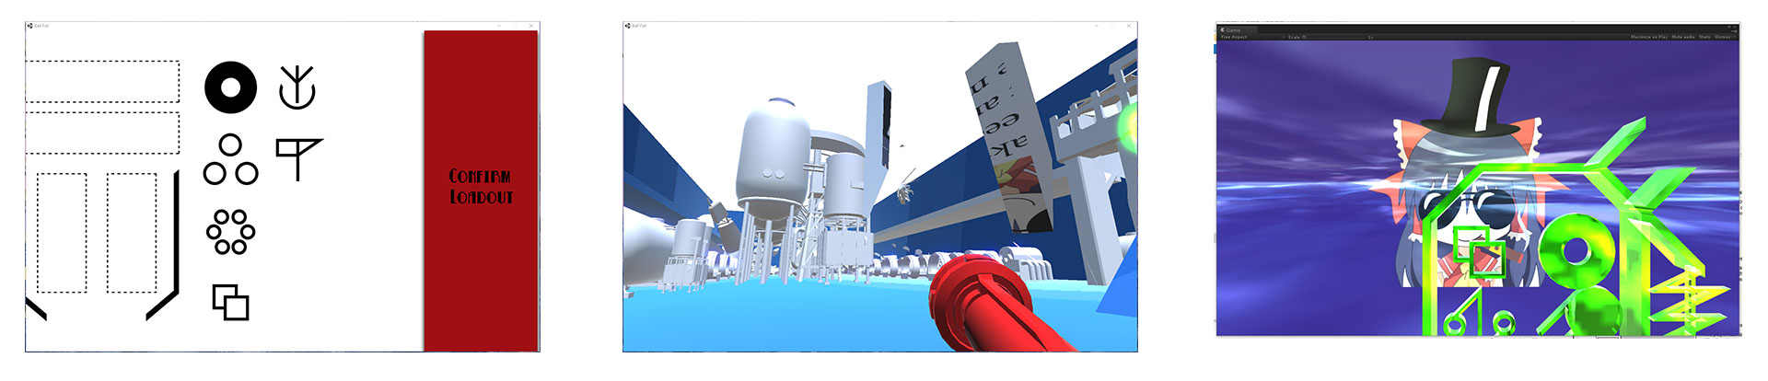

First, the player customizes the talisman, then destroy the factory as much as the player can and find out Hakurei for the final fight.

**Hakurei Talisman Factory**

Controller scheme

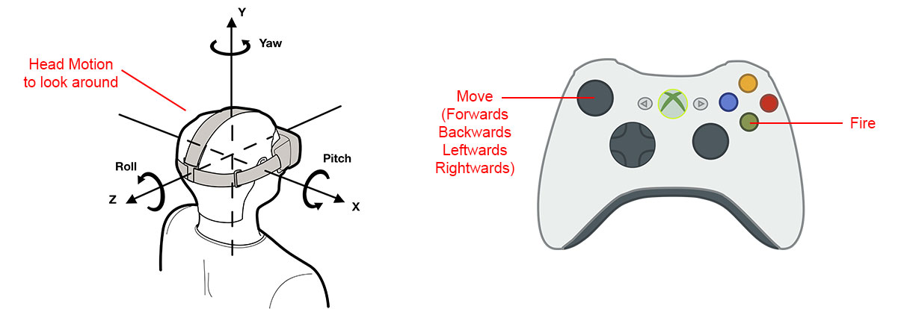

**Hakurei Talisman Factory**

Assets list

3D model of strokes and talisman frames

3D model of Hakurei and animation

3D model of the factory and destroy system and physical system

3D objects texture and materials (sky box, factory texture, stroke texture, talisman texture, Hakurei texture and so on)

Stroke and talisman shader

Flashing beam shader and particle system

Fireball shader and particle system

Shooting sound effect

Flashing beam sound effect

Fireball sound effect

Script of FPS and VR rendering

Google Cardboard VR API

Android platform player

**Hakurei Talisman Factory**

Accessories item list

VR goggles for phone, Wireless Bluetooth Android game controller, Android phone (Google Nexue6p is the testing device for the dev version)